**Iodine Deficiency**

Iodine is a trace mineral that is high in seafood, and is found in variable amounts in fruits and vegetables, depending on the iodine content of the local soil. In many parts of the world, the soils are naturally deficient in iodine, and **iodine deficiency disorders** and **hypothyroidism** will occur without iodine supplementation. Thyroid hormone has a crucial role in the development of the nervous system, being involved in the growth of synapses and the formation of myelin. **Endemic cretinism** is a disorder of cognitive development with reduced physical growth that occurs if thyroid hormone is deficient during gestation and early post-natal life. “Endemic” means prevalent in a particular region. This disorder is entirely preventable by making sure that pregnant women have sufficient iodine in their diet to be **euthyroid** (having adequate thyroid hormone levels). The World Health Organization is actively working to reduce iodine deficiency by supplying iodized salt to communities, and developing effective monitoring programs.

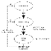**Goiter**is the term that means enlargement of the thyroid gland.  **Iodine deficient goiter** results because iodine is a crucial component of active thyroid hormones. If there is a low level of iodine in the diet, then less active T3 (triiodothyronine) and T4 (thyroxine) can be synthesized. As diagrammed in the figure, when there is less T3 and T4, there is reduced negative feedback inhibition of secretion of the tropic hormones, **TRH** (thyrotropin releasing hormone; released by the **hypothalamus**) and **TSH** (thyroid stimulating hormone or thyrotropin; released by the **anterior pituitary**). TSH stimulates all aspects of thyroid hormone synthesis; it also stimulates proliferation of follicle cells. When iodine in the diet is low but not too low, individuals may have goiter and yet be euthyroid, because the enlarged thyroid gland is better able to use the limited amount of iodine available. This is an example of how negative feedback regulation works to keep hormone secretion within the appropriate physiological range.

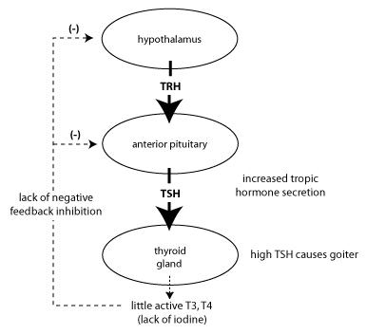

**Hashimoto's Thyroiditis**

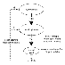The most common cause of hypothyroidism in the United States is due to **autoimmune destruction of the thyroid gland** that occurs in **Hashimoto’s thyroiditis**. In this case, antibodies to thyroid antigens, as well as infiltration by cytotoxic T cells, lead to destruction of thyroid tissue. Because the thyroid gland stores large amounts of thyroid hormone as thyroglobulin, a patient with Hashimoto’s thyroiditis may initially develop goiter, (which occurs due to inflammation), rather than symptoms due to hypothyroidism. As the store of thyroid hormone decreases, negative feedback inhibition *decreases*and ***TSH levels will rise***.

As Hashimoto's thyroiditis progresses, it will eventually lead to overt hypothyroidism. The symptoms of hypothyroidism result from decreased metabolic rate, and are opposite to the symptoms of hyperthyroidism. Patients may gain weight, feel sluggish and cold, and have a slowed heart rate. Hypothyroidism is treated with replacement therapy with thyroxine (T4).

